**SOURCE CODE:**

<!DOCTYPE html>

<html lang="en">

  <head>

    <meta charset="UTF-8" />

    <meta name="viewport" content="width=device-width, initial-scale=1.0" />

    <link

      rel="stylesheet"

      href="https://cdnjs.cloudflare.com/ajax/libs/font-awesome/6.4.2/css/all.min.css"

    />

    <title>Resume</title>

  </head>

  <body>

    <!-- Main Heading  -->

    <div style="display: flex">

      <img

        src="image.jpeg"

        alt="my_image"

        height="100"

        style="margin-right: 30px"

      />

      <div>

        <h2>FAISAL NAZIR</h2>

        <h4>Frontend Developer</h4>

      </div>

    </div>

    <!-- Introduction  -->

    <div>

      <h3>INTRODUCTION</h3>

      <p>

        I'm a front-end web developer who creates beautiful and easy-to-use

        websites using HTML, CSS, JavaScript and Bootstrap. I love designingand

        coding, and my goal is to make websites that attract customers and help

        businesses grow. I work well with others and keep up with the latest web

        trends to make sure my websites are up-to-date.

      </p>

    </div>

    <!-- Contact Information  -->

    <div>

      <h3>CONTACT INFORMATION</h3>

      <i class="fa-solid fa-phone-volume"></i>

      <p style="display: inline">03090842151</p>

      <br />

      <i class="fa-solid fa-envelope"></i>

      <a href="https://mail.google.com/">faisalnazir0306@gmail.com</a>

      <br />

      <i class="fa-solid fa-location-dot"></i>

      <a href="https://shorturl.at/iIKWY">SadiqAbad, District Rahim Yar Khan</a>

    </div>

    <!-- Technical Skill  -->

    <div>

      <h3>TECHNICAL SKILLS</h3>

      <ul>

        <li>HTML</li>

        <li>CSS</li>

        <li>JAVASCRIPT</li>

        <li>BOOTSTRAP</li>

        <li>REACT JS</li>

      </ul>

    </div>

    <!-- Educatoin  -->

    <h3>EDUCATION</h3>

    <div>

      <h4>

        BS(Hons) in Computer Science | GCU Lahore

        <pre style="display: inline">           2023</pre>

      </h4>

      <ul>

        <li>GPA : 3.2</li>

        <li>

          Thesis in Modelling and Analysis of Process Efficiency in a Cement

          Plant

        </li>

      </ul>

      <h4>

        FSc Pre-Engineering | MTB School & Colleges SadiqAbad

        <pre style="display: inline">           2018</pre>

      </h4>

      <ul>

        <li>Grade: A</li>

        <li>

          Developed a solid foundation in engineering principles and concepts.

        </li>

      </ul>

      <h4>

        Matric(Science) | Govt. High School Chak no. 148/p

        <pre style="display: inline">           2016</pre>

      </h4>

      <ul>

        <li>Grade: A<sup>+</sup></li>

        <li>

          Curiosity, knowledge, critical thinking unravel nature's wonders,

          shaping innovation through physics, chemistry, biology.

        </li>

      </ul>

    </div>

    <!-- Extracurricular activities  -->

    <h3>EXTRACURRICULAR ACTIVITIES</h3>

    <div>

        <ol>

            <li>

                Active member, attending workshops and meetups to expand knowledge in web development.

            </li>

            <li>

                Participated in coding events, fostering problem-solving skills and creativity.

            </li>

            <li>

                Passionate web developer with a commitment to continuous growth.

            </li>

        </ol>

    </div>

    <!-- Interest  -->

    <h3>INERTEST</h3>

    <div>

        <ul>

            <li>Creative Design</li>

            <li>Problem Solving</li>

            <li>Collaboration</li>

            <li>User Experince</li>

            <li>UI & UX Design</li>

            <li>Team Work</li>

        </ul>

    </div>

    <!-- Project  -->

    <h3>PROJECTS</h3>

    <div>

        <h4>Personal Desktop Assistant ( Aug 2022 - Feb 2023)</h4>

        <ul>

            <li>

                Developed <strong>"ARSENAL (PERSONAL ASSISTANT)"</strong> project, a voice-controlled assistant for automating daily tasks.

            </li>

            <li>

                Integrated rule-based systems and APIs to enable features like emailing, PDF reading, WhatsApp messaging, music playback, etc.

            </li>

            <li>

                Enabled voice commands to perform specific tasks, saving time and eliminating the need for typing.

            </li>

            <li>

                Improved efficiency and productivity by automating manual tasks.

            </li>

            <li>

                Implemented features like extracting space news, checking the timetable, sending email messages, and providing COVID-19 updates

            </li>

        </ul>

        <h4>Other Project (April 2023 - July 2023)</h4>

        <h4>Front end Project</h4>

        <ul>

            <li>

                <u>Project Background:</u>

            </li>

            <li>

                Introduce the need for an online presence for animal clinics due to increasing digitalization.

            </li>

            <li>

                Discuss the importance of a user-friendly and responsive website to attract clients and provide vital information.

            </li>

            <li>

                <u>Project Scope:</u>

            </li>

            <li>

                Outline the project's primary goal: to design and develop a responsive website for an animal clinic.

            </li>

            <li>

                Emphasize the utilization of HTML, CSS, and Bootstrap for efficient front-end development.

            </li>

            <li>

                <u>Design and Customization:</u>

            </li>

            <li>

                Describe the layout and visual design of the website, highlighting any custom graphics, color schemes, and typography choices.

            </li>

            <li>

                Explain how you've tailored the design elements to resonate with the animal clinic's branding and atmosphere.

            </li>

            <li>

               <u>Responsive Design:</u>

            </li>

            <li>

                Highlight the significance of responsive design, enabling the website to adapt seamlessly to various screen sizes, such as desktops, tablets, and smartphones

            </li>

            <li>

                Mention the implementation of Bootstrap's grid system to achieve this responsiveness effectively.

            </li>

        </ul>

    </div>

  </body>

</html>

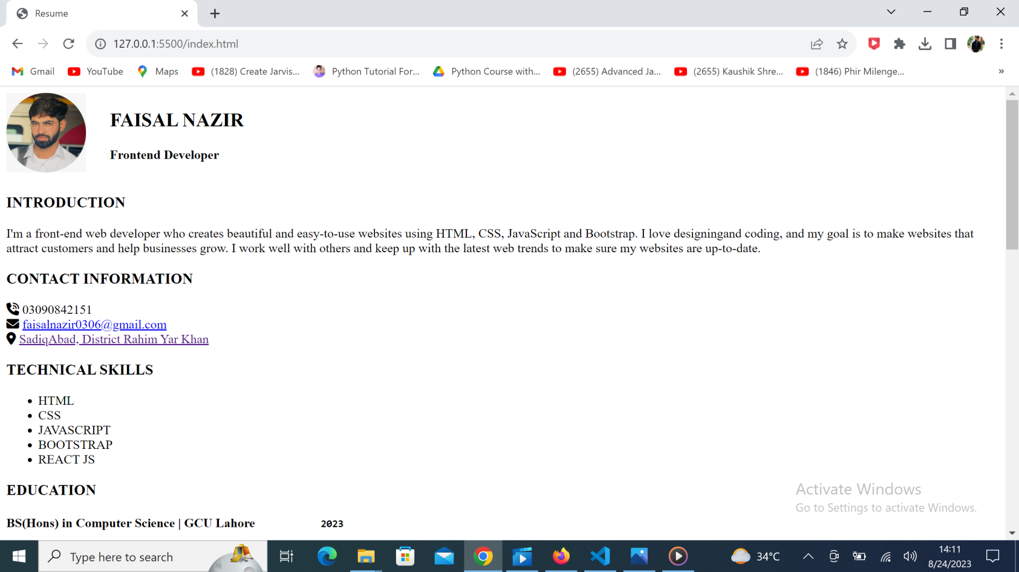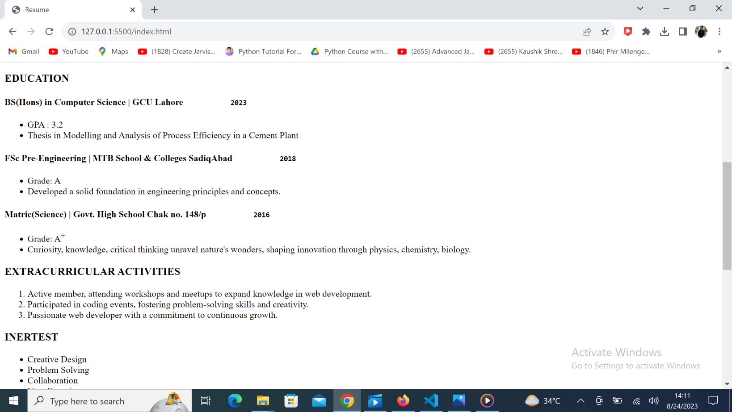

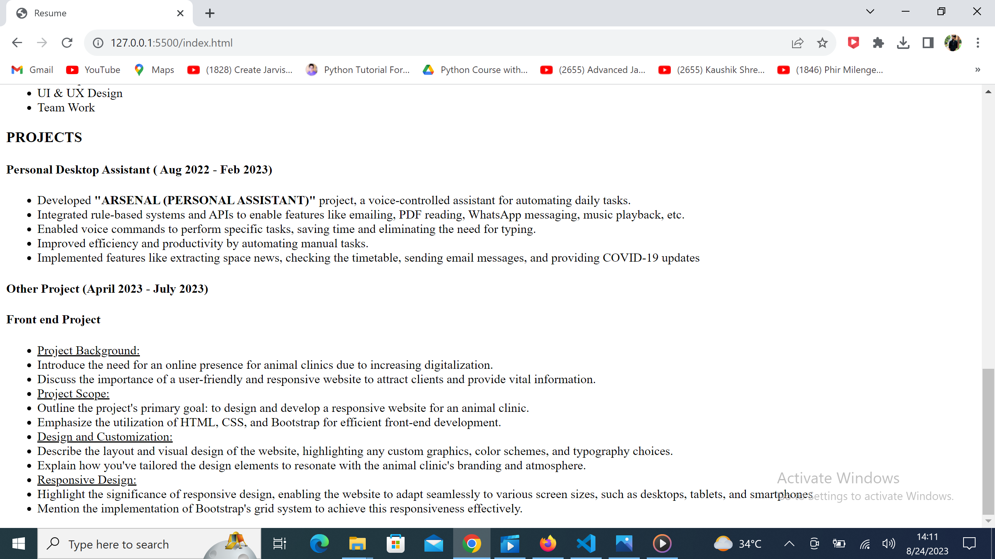

**HTML HIGHLIGHTS:**

**HTML Structure:**

**<!DOCTYPE html>**

Specifies the type of document as HTML5.

**<html>**

The root element of an HTML document.

**<head>**

Contains meta-information about the document such as character set, viewport settings, and links to external resources like stylesheets and scripts.

<meta charset="UTF-8">: Declares the character encoding for the document.

<meta name="viewport" content="width=device-width, initial-scale=1.0">: Sets the viewport properties for responsive design.

**<title>:** Sets the title of the web page, which is displayed on the browser tab.

**<head/>**

**<body>**

Contains the visible content of the webpage.

**<body/>**

**<html/>**

**HTML:**

* Html stands for Hyper Text Markup Language
* HTML is the code used to structure a web page and its content.
* The component used to design the structure of websites are called HTML tags
* We can use .htm or .html extensions for saving any html file.
* Like index.htm or index.html.

**HTML Tag:**

A container for some content or other HTML tags.

<p> This is a paragraph</p>

Here <p> is the opening tag and </p> is the closing tag.

**Comments in HTML**

This is part of the code that should not be parsed

<! -- This is an HTML Comment -->

**HTML is NOT case sensitive**

<p> = <P>

<html> = <HTML>

<head> = <HEAD>

<body> = <BODY>

**Basic HTML Tags**

**HTML Attributes**

Attributes are used to add more information to the tag

<html lang="en">

**Heading Tag**

Used to display headings in HTML

h1 (most important)

h3

h2

h4

h5

h6 (least important)

**Paragraph Tag**

Used to add paragraphs in HTML

<p> This is a sample paragraph </p>

**Anchor Tag**

Used to add links to your page

<a href="https:// Linkedin.com"> Linkedin </a>

**Image Tag**

Used to add images to your page

<img src="6.png" alt="Random Image">

**Br Tag**

Used to add next line(line breaks) to your page

<br>

**Bold, Italic & Underline Tags**

Used to highlight text on your page

<b> Bold </b>

<i> Italic </i>

<u> Underline </u>

**Big & Small Tags**

Used to display big & small text on your page

<big> Big </big>

<small> Small </small>

**Hr Tag**

Used to display a horizontal ruler, used to separate content

<hr>

**Page Layout Techniques:**

using Semantic tags for layout

<header>

<main>

<footer>

**Inside Main Tag**

**Section Tag**

<section>

For a section on your page

**Article Tag**

<article>

For an article on your page

**Aside Tag**

<aside>

For content aside main content (ads)

**Div Tag:**

Div is a container used for other HTML elements

Block Element (takes full width)

**List: Div Tags**

<address>

<article>

<aside>

<blockquote>

<canvas>

<dd>

<div>

<dl>

<dt>

<fieldset>

<figcaption>

<figure>

<footer>

<form>

<h1>-<h6>

<header>

<hr>

<li>

<main>

<nav>

<noscript>

<ol>

<p>

<pre>

<section>

<table>

<tfoot>

<ul>

<video>

**Span Tag:**

Span is also a container used for other HTML elements

Inline Element (takes width as per size)

**List: Span Tags**

<a>

<abbr>

<acronym>

<b>

<bdo>

<big>

<br>

<button>

<cite>

<code>

<dfn>

<em>

<i>

<img>

<input>

<kbd>

<label>

<map>

<object>

<tt>

<var>

<output>

<q>

<samp>

<script>

<select>

<small>

<span>

<strong>

<sub>

<sup>

<textarea>

<time>

**List in HTML:**

Lists are used to represent real-life list data.

**Unordered List**

<ul>

<li> English </li>

<li> urdu</li>

</ul>

**Ordered List**

<ol>

<li> English </li>

<li> Urdu </li>

</ol>

**Tables in HTML**

Tables are used to represent real-life table data.

<tr> used to display table row

<td> used to display table data

<th> used to display table header

**thead & tbody in Tables**

<thead> to wrap table head

<tbody> to wrap table body

**Form in HTML:**

Forms are used to collect data from the user

Eg- sign up/log in

<form>

form content

</form>

**Class & Id**

<div id="id1" class="group1">

</div>

<div id="id2"> class="group1">

</div>

**Video Tag**

<video src="myVid.mp4"> Video </video>

**Attributes**

- controls

- height

- width

- loop

- autoplay